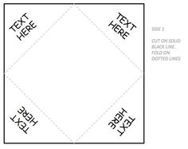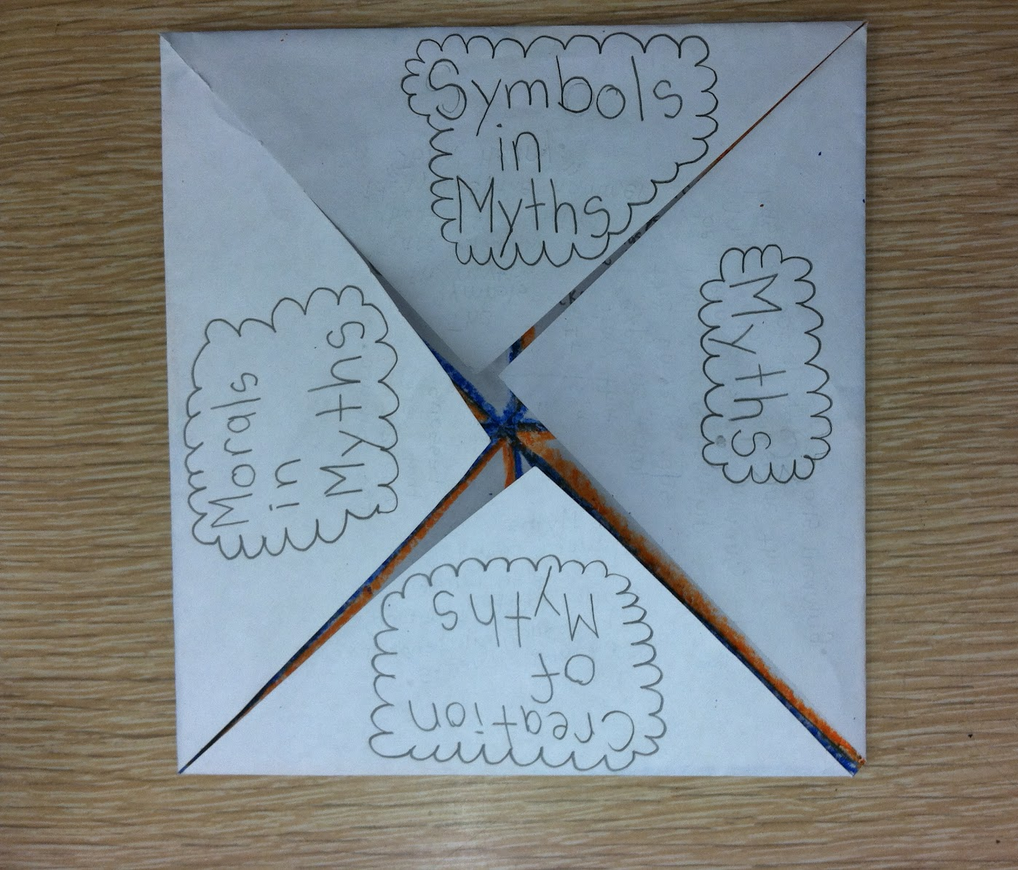
9x9 square

Center Section: Title: Critical Thinking in Literature
Draw the symbol represented in item #3.

Each outside flap needs the title of the element: Historical Context, Theme, Symbolism, Characterization

Each inside flap needs a section of literary analysis.
- Historical Context: How authentic is the culture or era represented in the book? Provide two pieces of evidence for setting authenticity.

- Theme: Track the theme over the course of the novel. Provide three experiences of the protagonist/antagonist that demonstrate the evolution of the author’s theme/message based on these observations.

- Symbolism: Identify and explain a symbol and its implications on the plot development or the development of a character.

- Characterization: How were the secondary characters important to the story?

*On the back of the foldable (opposite of the flaps) label the student name, period, book title and author as well as provide the MLA citation for the book.

