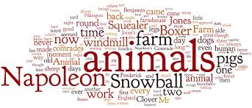

Animal Farm Reading/Quiz Schedule

Assignment Due Date

Chapters 1-3 Monday 2/5
Tuesday 2/6

Chapters 4-6 Monday 2/12 Tuesday 2/13

Chapters 7-8 Friday 2/16

Chapters 9-10 Tuesday 2/20
Wednesday 2/21

